3.(B)

EMPRICAL DISTRIBUTION FUNCTION OUTPUT:

-> 0.087,0.1305,0.2609,0.4783,0.6522,0.7392,0.9131,1

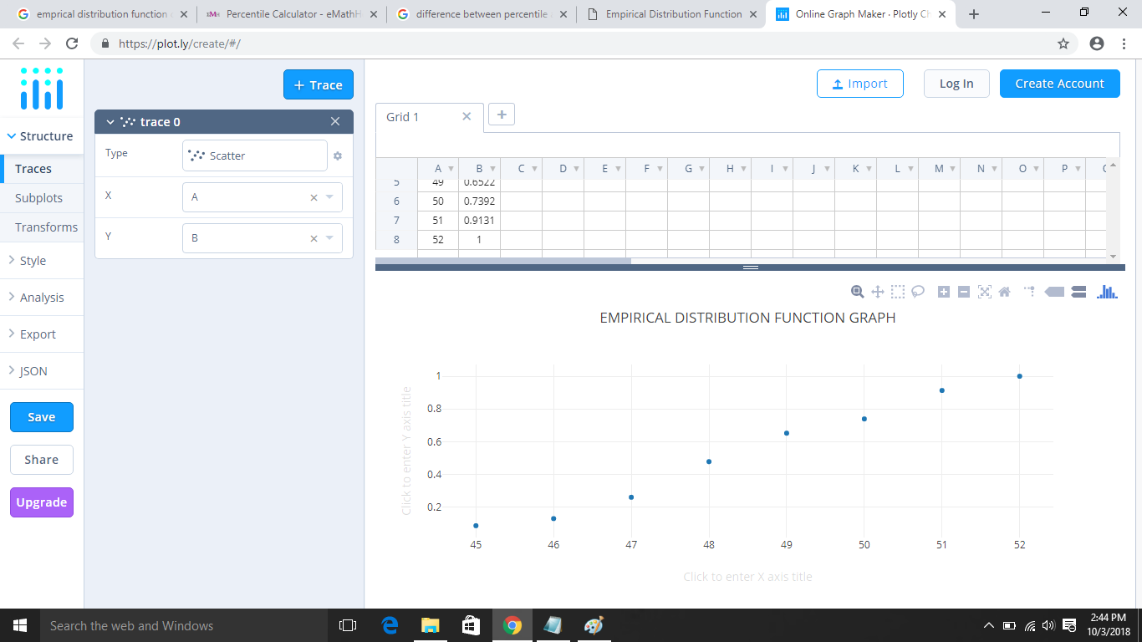

3.(C)

(I)10% quantile=0.087

(II)40% quantile=0.4783

(III)75% quantile=0.9131

MEDIAN=0.6522